Glossary: terms used in species descriptions
Cell shape
Shape of cell end or cell part

acicular – needle-shaped
acute – sharp angle (<90 degrees)
akinete – in cyanobacteriophyta: a type of spore formed by the transformation of a vegetative cell into a thick-walled resting cell, containing concentrated food material
alkalinity – mg CaCO₃ L⁻¹
amoeboid – amoeba like
anterior – situated at the front side, opposite of posterior
antapex – the point opposite to the tip of the cell on its other end
antapical – opposite to the tip of the cell on its other end
apex (plural: apices) – tip of a cell (in species that have one or more attenuated endings)
apical axis – in diatoms: axis linking the two poles of a valve
apiculate – terminating in a short, sharp, flexible point. In diatoms: having a short broad tip see Cox (1996) Fig. 6
aplanospores – non-motile spores formed asexually within the parent cell, having no flagella
arcuate – curved bow-shaped see Cox (1996) Fig. 5
areola (plural: areolae) – a regular, repeated perforation through the siliceous layer on the valve of a diatom cell
athecate – in dinoflagellates: ‘naked’, not having thecae, not being enclosed in a shell of cellulose plates
attenuated – long, narrow and sometimes tapering
autogamy – non-sexual reproduction, self-fertilization or conjugation in an individual organism by division of its nucleus into two parts that in turn reunite to form a zygote
auxospore – large cell resulting from sexual reproduction or autogamy. In diatoms, they lack the rigid valves, instead they are covered by delicate siliceous scales or bands
axial – along the axis

bilateral symmetry – symmetry about a single middle line
broad linear – see Cox (1996) Fig. 5

capitate – having a part that is enlarged and rounded (like a head) see Cox (1996) Fig. 6
caudus – ‘tail’ of euglenophytes
cingulum (plural: cingula) – portion of the diatom girdle associated with a single valve. In dinoflagellates: a transverse groove that encircles the cell and holds the transverse flagellum in place.
conductivity – specific conductance, μS cm⁻¹
conjugation – a form of sexual reproduction where neither gamete is flagellated. This type of reproduction, typical of the Zygnematalean (conjugating) green algae, cells attach to each other so that the gametes can fuse.
costa (Plural: costae) – rib-like longitudinal cell wall thickening
cuneate - see Cox (1996) Fig. 6

dorsal – back side, opposite of ventral
dorsiventral – in diatoms: a cell with different curvature to its two sides connecting the apices see Cox (1996) Fig. 6

epitheca – in dinoflagellates: the upper theca of the dinoflagellate cellulose shell, which together with the hypotheca makes a full cell covering.
eulittoral zone – the lake region between maximum and minimum water level.
eyespot – light-sensitive, typically red-colored (carotenoid pigments) spot or organelle in algal cells

fibula (plural: fibulae) – in diatoms: a bridge of silica between portions of the valve on either side of the raphe
flagellum (plural: flagella) – long, thread-like organelle that projects out of the cell and functions in motility
frustule – the cell wall of a diatom cell, composed of silica, comprised of two valves and a series of linking bands, the girdle
fusiform – elongated shape that is widest in the middle and tapering towards the ends. Spindle shape. Like an American football

gamete – sex cell
gametangium (plural: gametangia) – a cell containing the gametes
girdle – the region in a diatom frustule (shell) where the two valves overlap
girdle view – in diatoms, the way the cell looks under the microscope when examined looking at the girdle of the cell (as opposed to the valve view, i.e. looking at the valve face of the cell)
gullet – a longitudinal depression in the upper part of a cryptophyte, chrysophyte or euglenophyte cell from which a flagellum or flagella emerge

haptonema – a thread-like appendage between the 2 flagella of Haptophytes
heterocyte – a thick-walled, non-pigmented cell of nostocalean cyanobacteriophyta that is different from adjacent vegetative cells and where N-fixation takes place.
heteropolar – having different poles. In diatoms: with apices of differing size and/or shape
hyaline – colorless, translucent, clear
hypotheca – in dinoflagellates: the lower theca of the dinoflagellate cellulose shell, which together with the epitheca makes a full cell covering

intercalary cell – located between two other cells in a filament
isogamous (isogamy) – sexual reproduction in which two types of gametes are morphologically indistinguishable, although functionally they are different.
isopolar – having the same poles. In diatoms: with apices of the same size and shape
isthmus – in desmids: the narrow mid-region of the cell connecting the two semicells; the nucleus is located in this mid-region

lamellate – composed of thin layers or plates. Also used to refer to successive layers of mucilage
laminate – reefers to layers or plates overlying one another
lanceolate – lance-shaped, with the broadest part usually about 1/3 of the distance from abse and usually tapering towards each endsee Cox (1996) Fig. 5

linear – see Cox (1996) Fig. 5
linear-lanceolate – see Cox (1996) Fig. 5
lorica – a protective case containing a naked (non-walled) cell
lunate – shape of a moon in its first quarter. see Cox (1996) Fig. 5

mantle – see valve mantle
metaphytic - algae normally loosely attached to a surface but occasionally becoming detached and incorporated into the plankton
oogamy (oogamous) – sexual reproduction in which there is a fusion of a smaller flagellated male gamete (e.g. spermatozoid) with a larger, non-flagellated female gamete (e.g. egg or oogonium)
oogonium (plural: oogonia) – large, single-celled female gametanium that may produce one or more eggs.

papilla – (plural: papillae) protuberance or swelling
paramylon – a carbohydrate stored in euglenophytes in ‘paramylon bodies’
parietal – positioned by the cell wall
pentangular – having 5 sides
pellicle – in euglenoids, the outer proteinaceous cell surface layer (or peripheral protoplasmic layer), often in a spiral arrangement
posterior – situated at the rear or back side, opposite of anterior
process – a part that naturally grows on or sticks out on an organism
protoplast – the living material inside a cell. In thecate dinoflagellates the protoplasts are membrane-bound and can emerge out of their thecae
puncta (singular: punctum) – minute depressions on the diatom valve or the desmid cell wall
punctate – ornamented with dots (=puncta)
pyrenoid – organelle, often spherical, associated with the chloroplast containing the enzyme Rubisco
pyriform – pear-shaped
radial symmetry – symmetry resembling that of a pie, where several cutting planes produce roughly identical pieces. There is no left or right side, only top (dorsal) and bottom (ventral) sides
raphe – in diatoms, a pair of slit-like structures in one or both valves associated with the gliding movement
reniform – kidney shaped
resting cyst –non-motile stage in the dinoflagellate life cycle, when the cell is enveloped by a thick cell wall and rests on the bottom sediments till conditions become favorable for vegetative growth
reticulate – net-shaped (with holes)
retuse – having the end rounded with slight indentation; like a retuse leaf
rostrate – see Cox (1996) Fig. 6

scalariform conjugation – ladder-like; in members of conjugatophycea a type of conjugation where the conjugation tube forms between two parallel filaments
septum (plural: septa) – in diatoms: cross-partitioning on a girdle element projecting into or dividing a cell into chambers
serrulate – finely serrated. Having a finely notched edge like the teeth of a saw
sheath – covering or envelope surrounding the cell wall, usually mucilaginous
sinus – in desmids: the median incision dividing the desmid cell into two semicells
spinule(s) – minute spine or thorn-like projection(s)
stellate – star-shaped
sternum – in diatoms: a hyaline region, without striae, running a long the long axis of a valve in araphid diatoms
stigma – see: eyespot
stria (plural: striae) – stripe(s), line of pores on the diatom valve
subaerophytic – from terrestrial habitats which receive occasional or partial moisture, such as dripping rocks
subcapitate – see Cox (1996) Fig. 6
subrostrate – see Cox (1996) Fig. 6
sulcus – in dinoflagellates: a longitudinal groove in the ventral face of the cell, in hypotheca/hypocone that may extend into the epitheca/epicone; hold the longitudinal whiplash flagellum
suture – Line or groove, especially in desmids, marking the limits between adjacent semicells. In filamentous zygnematales: groove around zygospore. In armored dinoflagellates: groove between the plates
synonym - superseded or unused name

tapering – narrowing, ending in a point
theca (Plural: thecae) – in dinoflagellates: a cell covering made of cellulose plates. Usually each cell has 2 thecae (an epi-theca and a hypo-theca), which together fully encase the cell
thecate – in dinoflagellates: having thecae, being enclosed in a shell of cellulose plates which makes the cell look ‘armored’
tychoplanktonic – species that are predominantly planktonic but are capable of prolonged survival on or in sediments
transapical axis – in diatoms: axis linking the mid-points of opposing valve margins, intersecting the middle of the apical axis
transverse – passing through a hyperbola’s foci
trichome – in cyanobacteriophyta: a filament, but without the sheath. The term is synonymous with filament for forms which never possess a sheath, but for those which do, the filament consists of a trichome and a sheath
trichocyst – in cryptophytes, dinoflagellates and raphidophytes: membrane surrounded organelle lying beneath the cell surface, which ejects threads of mucilage on stimulation
truncate – cut off, trimmed, as opposed to being rounded or pointed.

undulate (adj) – with a wavy appearance, edge or marking
undulation – a curving form or outline, especially one in a series such as a wave

valve – one of two halves of the diatom silicaceous shell (=frustule). The two valves usually have the same shape, but since one fits into the other as in a petri dish, they are of different size
valve face – the round part of the valve
valve mantle – the marginal part of the valve, differentiated by slope and/or structure
valve margin – the edge of the valve where the cingulum begins
valve view – in diatoms, the way the cell looks under the microscope when examined looking at the valve face of the cell (as opposed to the girdle view, i.e. looking at the side face of the cell)
ventral – front side, opposite of dorsal
verruca (Plural: verrucae) – wart(s) or spiny projection(s)
verrucose – covered with warty or spiny projections

zoospore – motile asexual spore
zoosporangium – cell producing zoospores
zygospore – thick-walled resting spore formed sexually by the fusion of two gametes

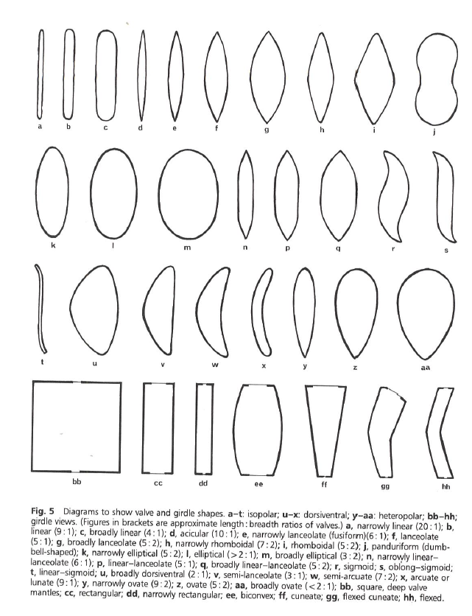
Plate 1. Fig. 5 from: Cox EJ 1996. Identification of freshwater diatoms from live material. London: Chapman & Hall. P. 6
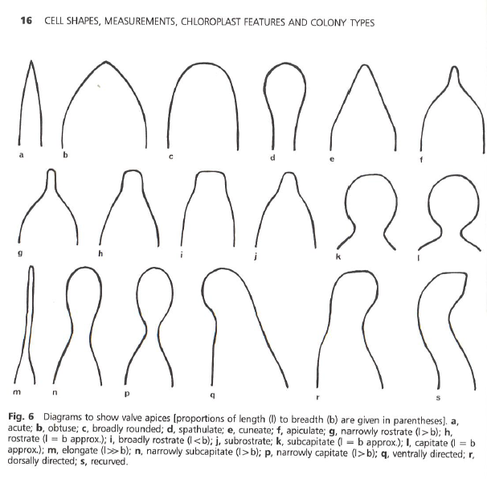
Plate 2. Fig. 6 from: Cox EJ 1996. Identification of freshwater diatoms from live material. London: Chapman & Hall. P. 16

